**Problem Statement:**

link:emp_details.txt

Use Hive Scripts to run the below queries.

● Get a list of employees who receive a salary less than 100, compared to their immediate employee with higher salary in the same unit

● List of all employees who draw higher salary than the average salary of that department

Problem Statement:

Link: olympic_data.csv

Store the above dataset into the following file formats.

● SEQUECEFILE

● RCFILE

● ORC FILE

Share the commands used with their results.

**Creating and loading the database**

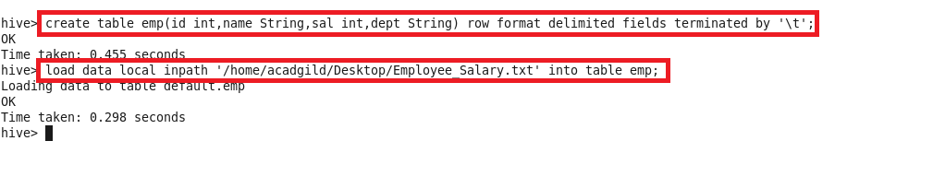

● Get a list of employees who receive a salary less than 100, compared to their immediate employee with higher salary in the same unit

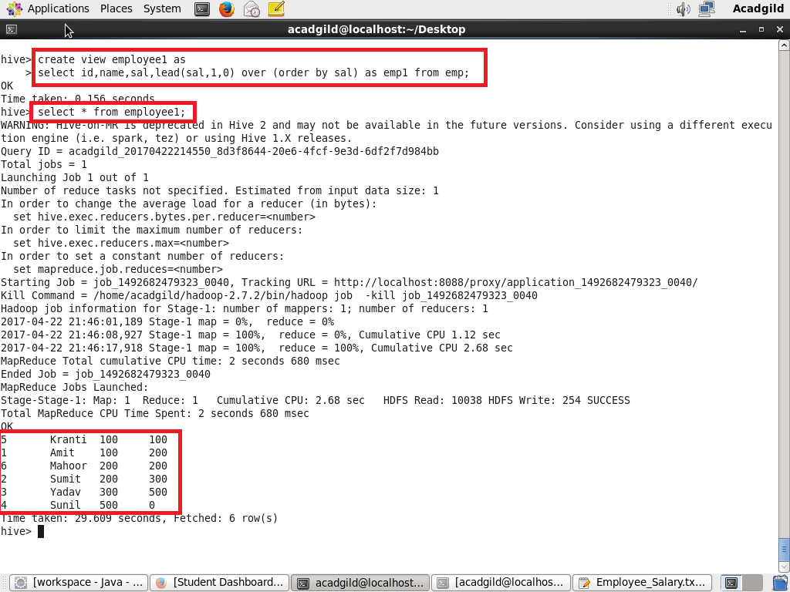

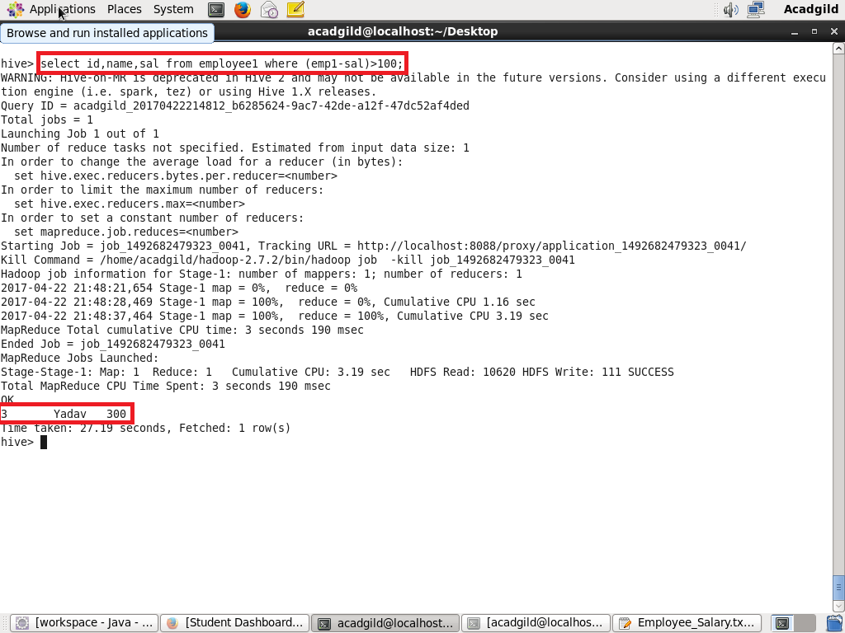

● List of all employees who draw higher salary than the average salary of that department

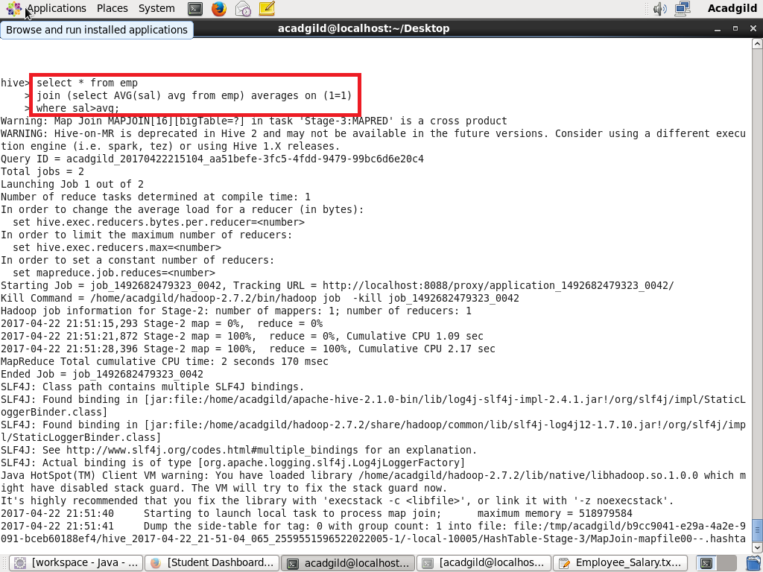

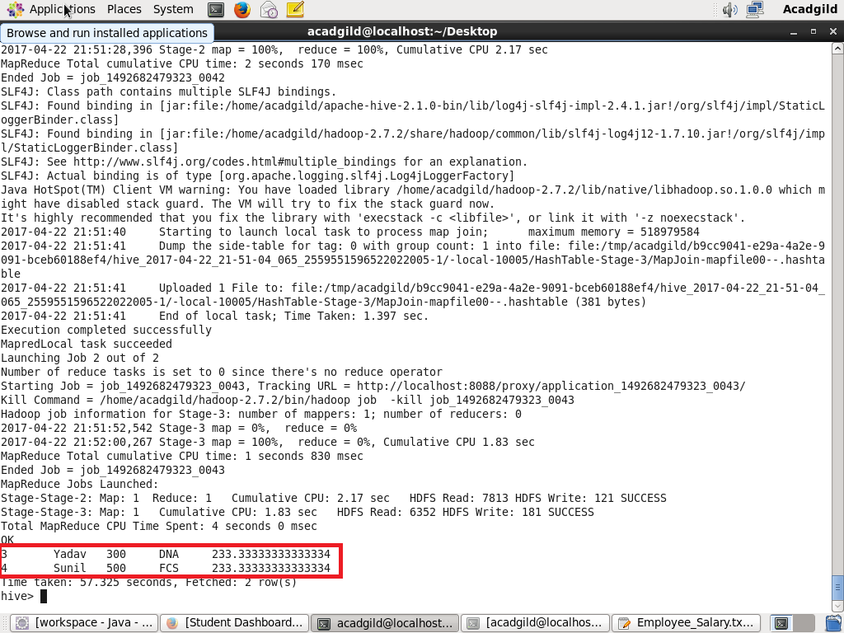

Store the above dataset into the following file formats

**SEQUECEFILE**

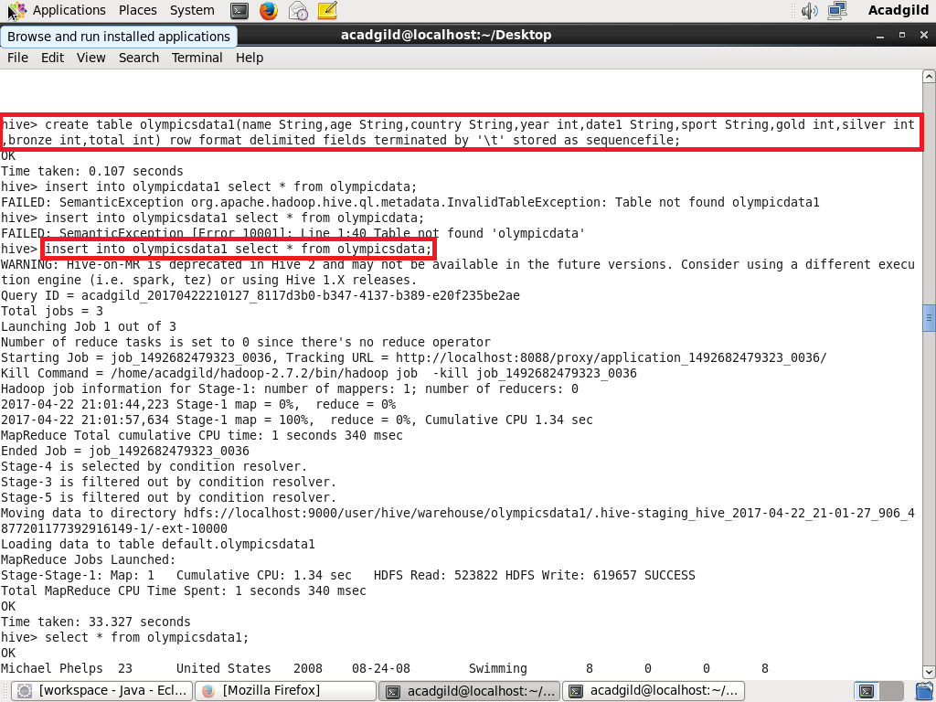

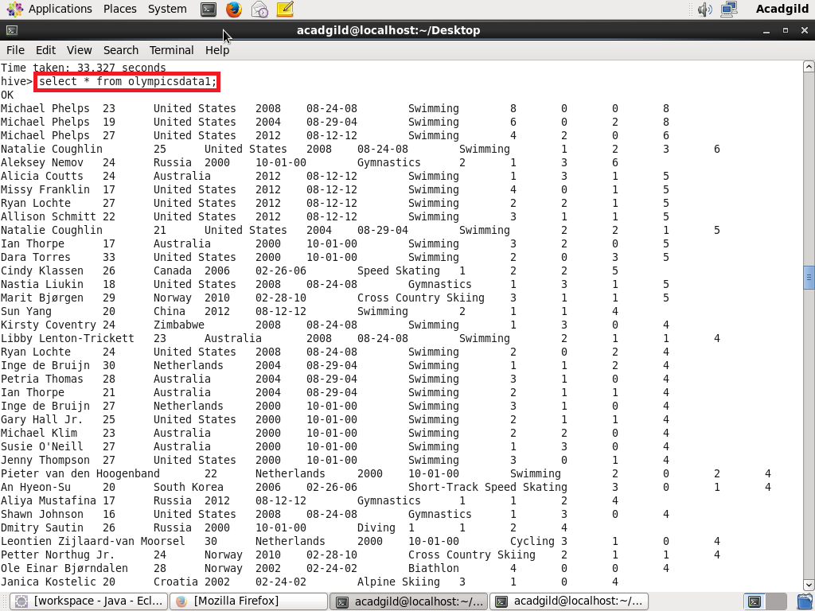

**RCFILE**

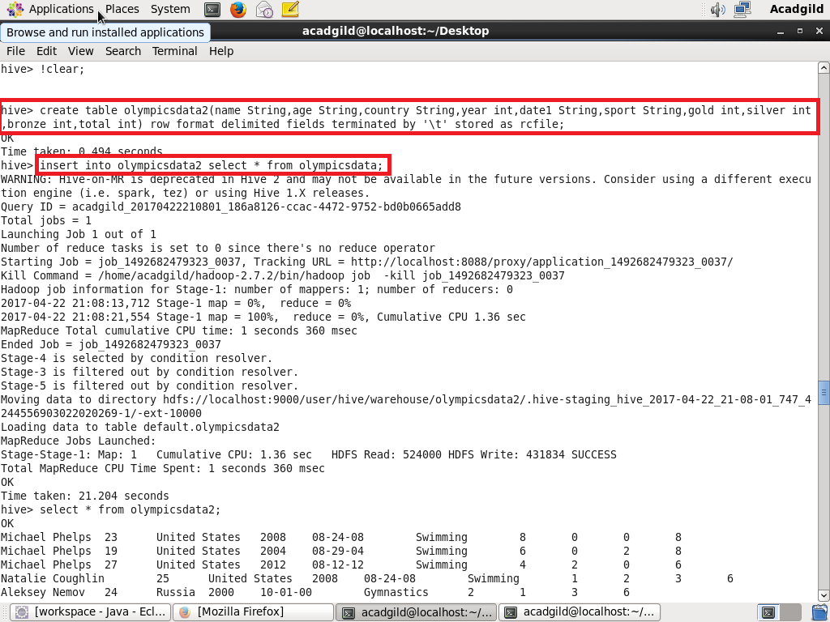

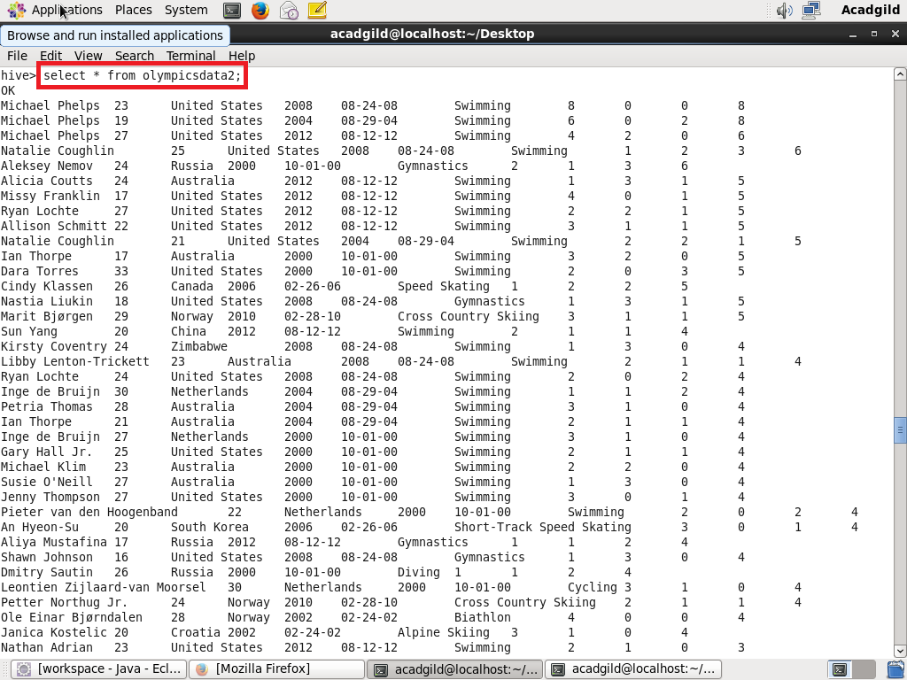

**ORC FILE**

